Gladstone Regional Council

Animal Management (Amendment) Subordinate Local Law (No. 1) 2019

Contents



Part 1 Preliminary 1

1 Short title 1

2 Subordinate local law amended 1

Part 2 Amendments to subordinate local law 1

3 Amendment of s9 (Identification for dogs in certain circumstances—Authorising local law, s9) 1

4 Amendment of s17 (Animals that may be disposed of without auction or tender—Authorising local law, s32(1)(b)) 1

5 Amendment of sch1 (Prohibition on keeping animals) 1

6 Amendment of sch2 (Requirement for approval to keep animal) 2

7 Amendment of sch5 (Minimum standards for keeping particular animals) 3

8 Amendment of sch6 (Prohibition of animals in public places) 3

9 Amendment of sch7 (Dog off-leash areas) 4

10 Amendment of sch13 (Dictionary) 8

Part 1 Preliminary

1. Short title

This subordinate local law may be cited as *Animal Management (Amendment) Subordinate Local Law (No. 1) 2019*.

1. Subordinate local law amended

This subordinate local law amends *Subordinate Local Law No. 2 (Animal Management) 2011.*

Part 2 Amendments to subordinate local law

1. Amendment of s9 (Identification for dogs in certain circumstances—Authorising local law, s9)

Section 9, ‘section 12(3)’—

*omit, insert—*

‘section 12(2)’.

1. Amendment of s17 (Animals that may be disposed of without auction or tender—Authorising local law, s32(1)(b))
2. Section 17(c), ‘.’—

*omit, insert—*

‘; and’.

1. After section 17(c)—

*insert—*

‘(d) stock.’.

1. Amendment of sch1 (Prohibition on keeping animals)
2. Schedule 1, column 1, heading, ‘**Animal**’**—**

*omit, insert—*

‘**Animal**[1]1A’.

1. Schedule 1, item 1, column 2, paragraph (b), ‘1 dog’—

*omit, insert—*

‘2 dogs’.

1. Schedule 1, column 2, item 3(d) —

*omit, insert—*

‘(d) subject to item 4A, more than 4 horses on an allotment with an area between 10001m2 and 20000m2.’.

1. Schedule 1, column 2, item 4(3)—

*omit, insert—*

‘(3) Subject to item 4A, more than 4 animals to which this item 4 applies on an allotment with an area between 10000m2 and 20000m2.’.

1. Schedule 1, after item 4—

*insert—*

‘

|  |  |  |
| --- | --- | --- |
| 4A | Horse, donkey, cow, bull, camel, deer, sheep, goat, llama or pig | 1. This item 4A applies to all of the following—    1. a horse;    2. a donkey;    3. a cow;    4. a bull;    5. a camel;    6. a deer;    7. other domesticated animals of a similar size;    8. a sheep;    9. a goat;    10. a llama;    11. other domesticated animals of a similar size;    12. a pig. 2. More than 6 animals to which this item 4A applies on an allotment with an area between 10000m2 and 20000m2. |

’.

1. Schedule 1, item 7, column 1, ‘Duck,’—

*omit.*

1. Schedule 1, item 7, column 1, ‘goose’—

*omit, insert—*

‘Goose’.

1. Schedule 1, item 7, column 2, subsection (1)(a)—

*omit*.

1. Schedule 1, item 7, column 2, subsection (1)(b), (c) and (d)—

*renumber* as subsection (1)(a), (b) and (c).

1. Amendment of sch2 (Requirement for approval to keep animal)
2. Schedule 2, item 1, from ‘3 or 4’ to ‘more.’—

*renumber* as item 1(a).

1. Schedule 2, after item 1(a)—

*insert*—

‘(b) 2 dogs over the age of 3 months on premises which are multi‑residential premises.’.

1. Amendment of sch5 (Minimum standards for keeping particular animals)
2. Schedule 5, column 1, heading, ‘**animal**’—

*omit, insert—*

‘**animal**[2]1B’.

1. Schedule 5, column 2, item 3(f), ‘.’—

*omit, insert—*

‘; and’.

1. Schedule 5, column 2, after item 3(f)—

*insert—*

‘(g) if the bird has the ability to escape from the enclosure by flying out of the enclosure — the enclosure in which the bird is kept is fitted with a roof, or cover, which prevents the bird from escaping from the enclosure by flying out of the enclosure.’.

1. Amendment of sch6 (Prohibition of animals in public places)
2. Schedule 6, column 2, heading, ‘**animals**’—

*omit, insert—*

‘**animals**[3]1C’.

1. Schedule 6, items 2 and 3—

*omit.*

1. Schedule 6, items 4 to 11 inclusive—

*renumber* as items 2 to 9 inclusive.

1. Schedule 6, column 2, item 3, from ‘All’ to ‘prohibited’—

*omit, insert—*

‘All species and breeds of animal other than—

(a) dogs; and

(b) other animals which are permitted to be in the public place under an approval granted by the local government under *Local Law No. 1 (Administration) 2011* for the undertaking of a prescribed activity at the public place.’.

1. Schedule 6, column 2, item 4, from ‘All’ to ‘prohibited’—

*omit, insert—*

‘All species and breeds of animal other than—

(a) dogs; and

(b) other animals which are permitted to be in the public place under an approval granted by the local government under *Local Law No. 1 (Administration) 2011* for the undertaking of a prescribed activity at the public place.’.

1. Footnotes 1A, 1, 1B, 1C and 2—

*renumber* as footnotes 1, 2, 3, 4 and 5.

1. Amendment of sch7 (Dog off-leash areas)
2. Schedule 7—

*insert—*

‘9. The fenced area shown hatched in black and bounded by a bold black line on the map titled “Bunting Park – Calliope Off Leash Area” which forms part of this schedule 7 being part of the land described as Lot 158 on Plan CTN1533.

10. The area shown hatched in black and bounded by a bold black line on the map titled “Dog Agility Area – Memorial Park Bororen” which forms part of this schedule 7 at Memorial Park Bororen and which is described as part of Lot 255 on Plan CP858947.

11. The area of bathing reserve, foreshore and esplanade shown hatched in black and bounded by a bold black line on the map titled “Boyne River Foreshore and adjacent Dunal Area which forms part of this schedule 7 from the mouth of the Boyne River north of Wyndham Park to Lilley’s Inlet, but only during the months of a year from April to October inclusive.’.

1. Schedule 7—

*insert—*

‘

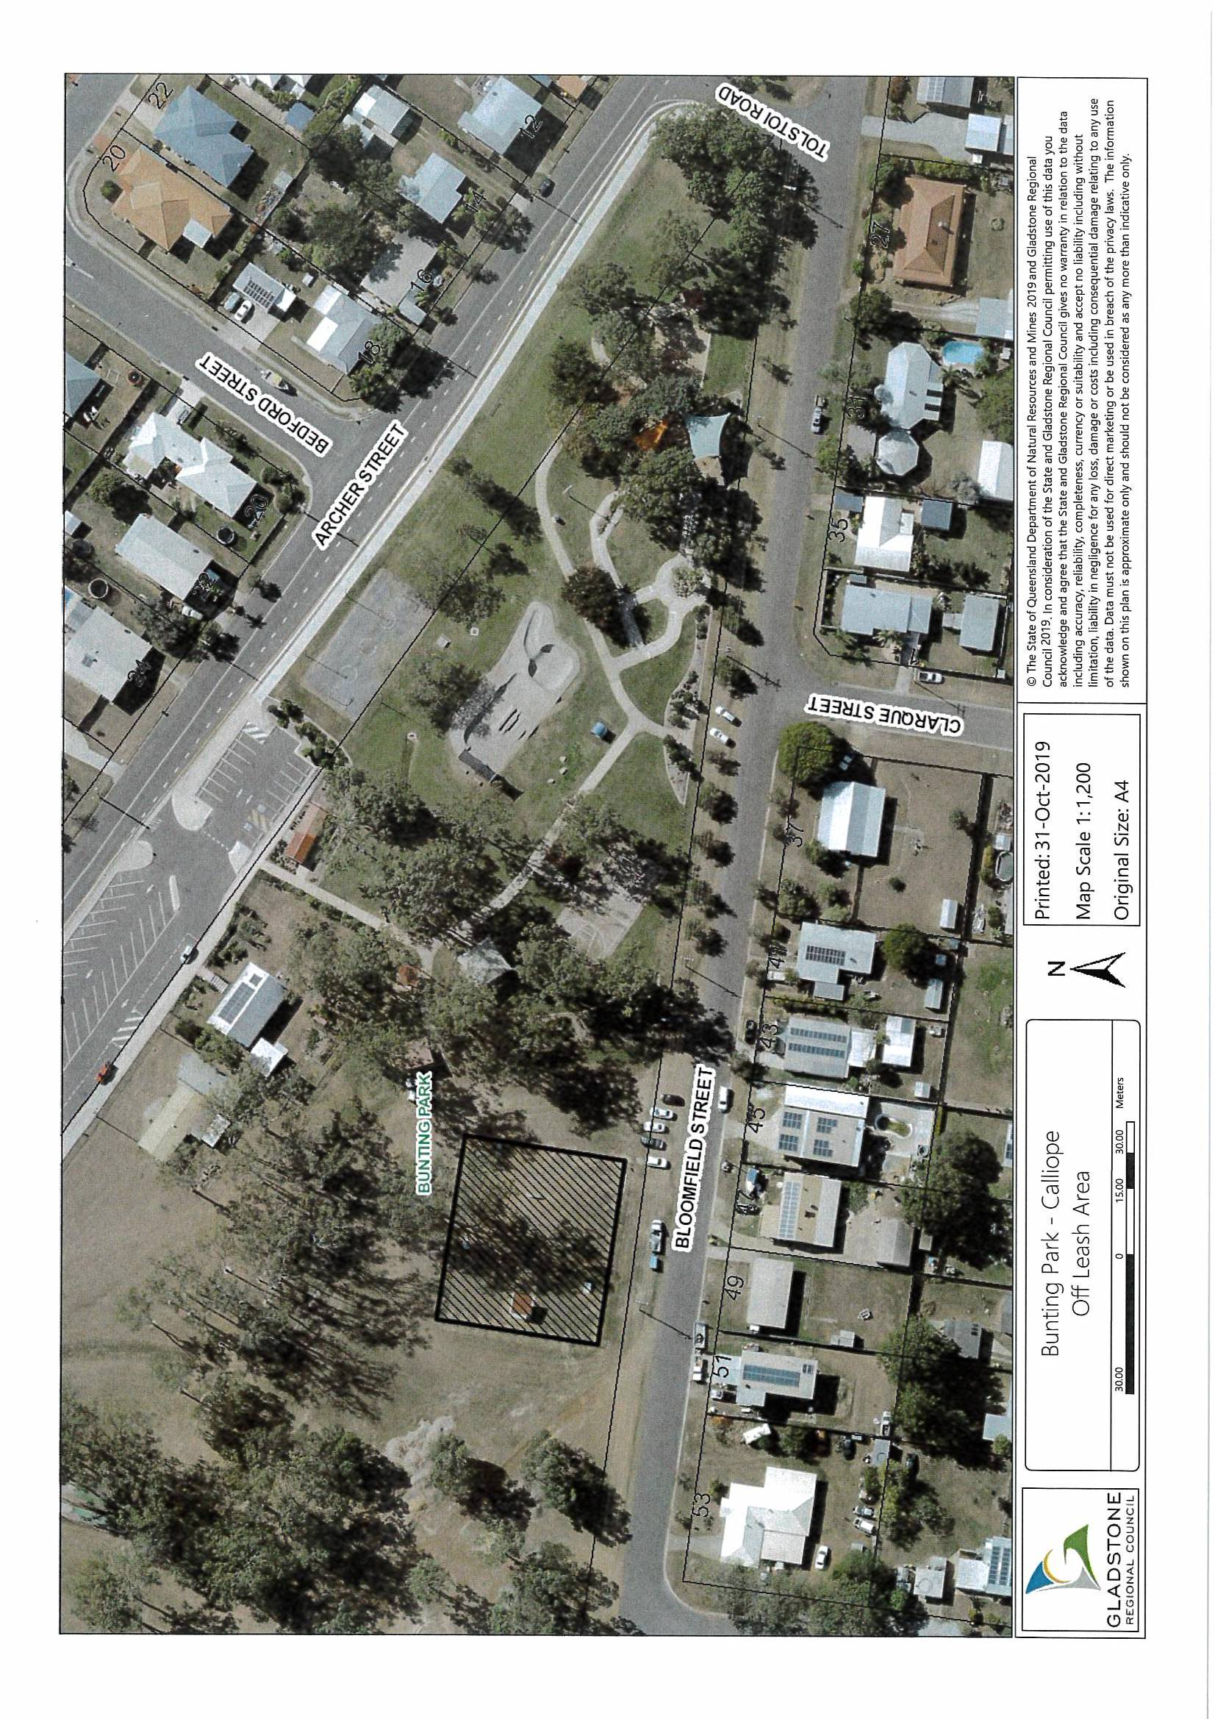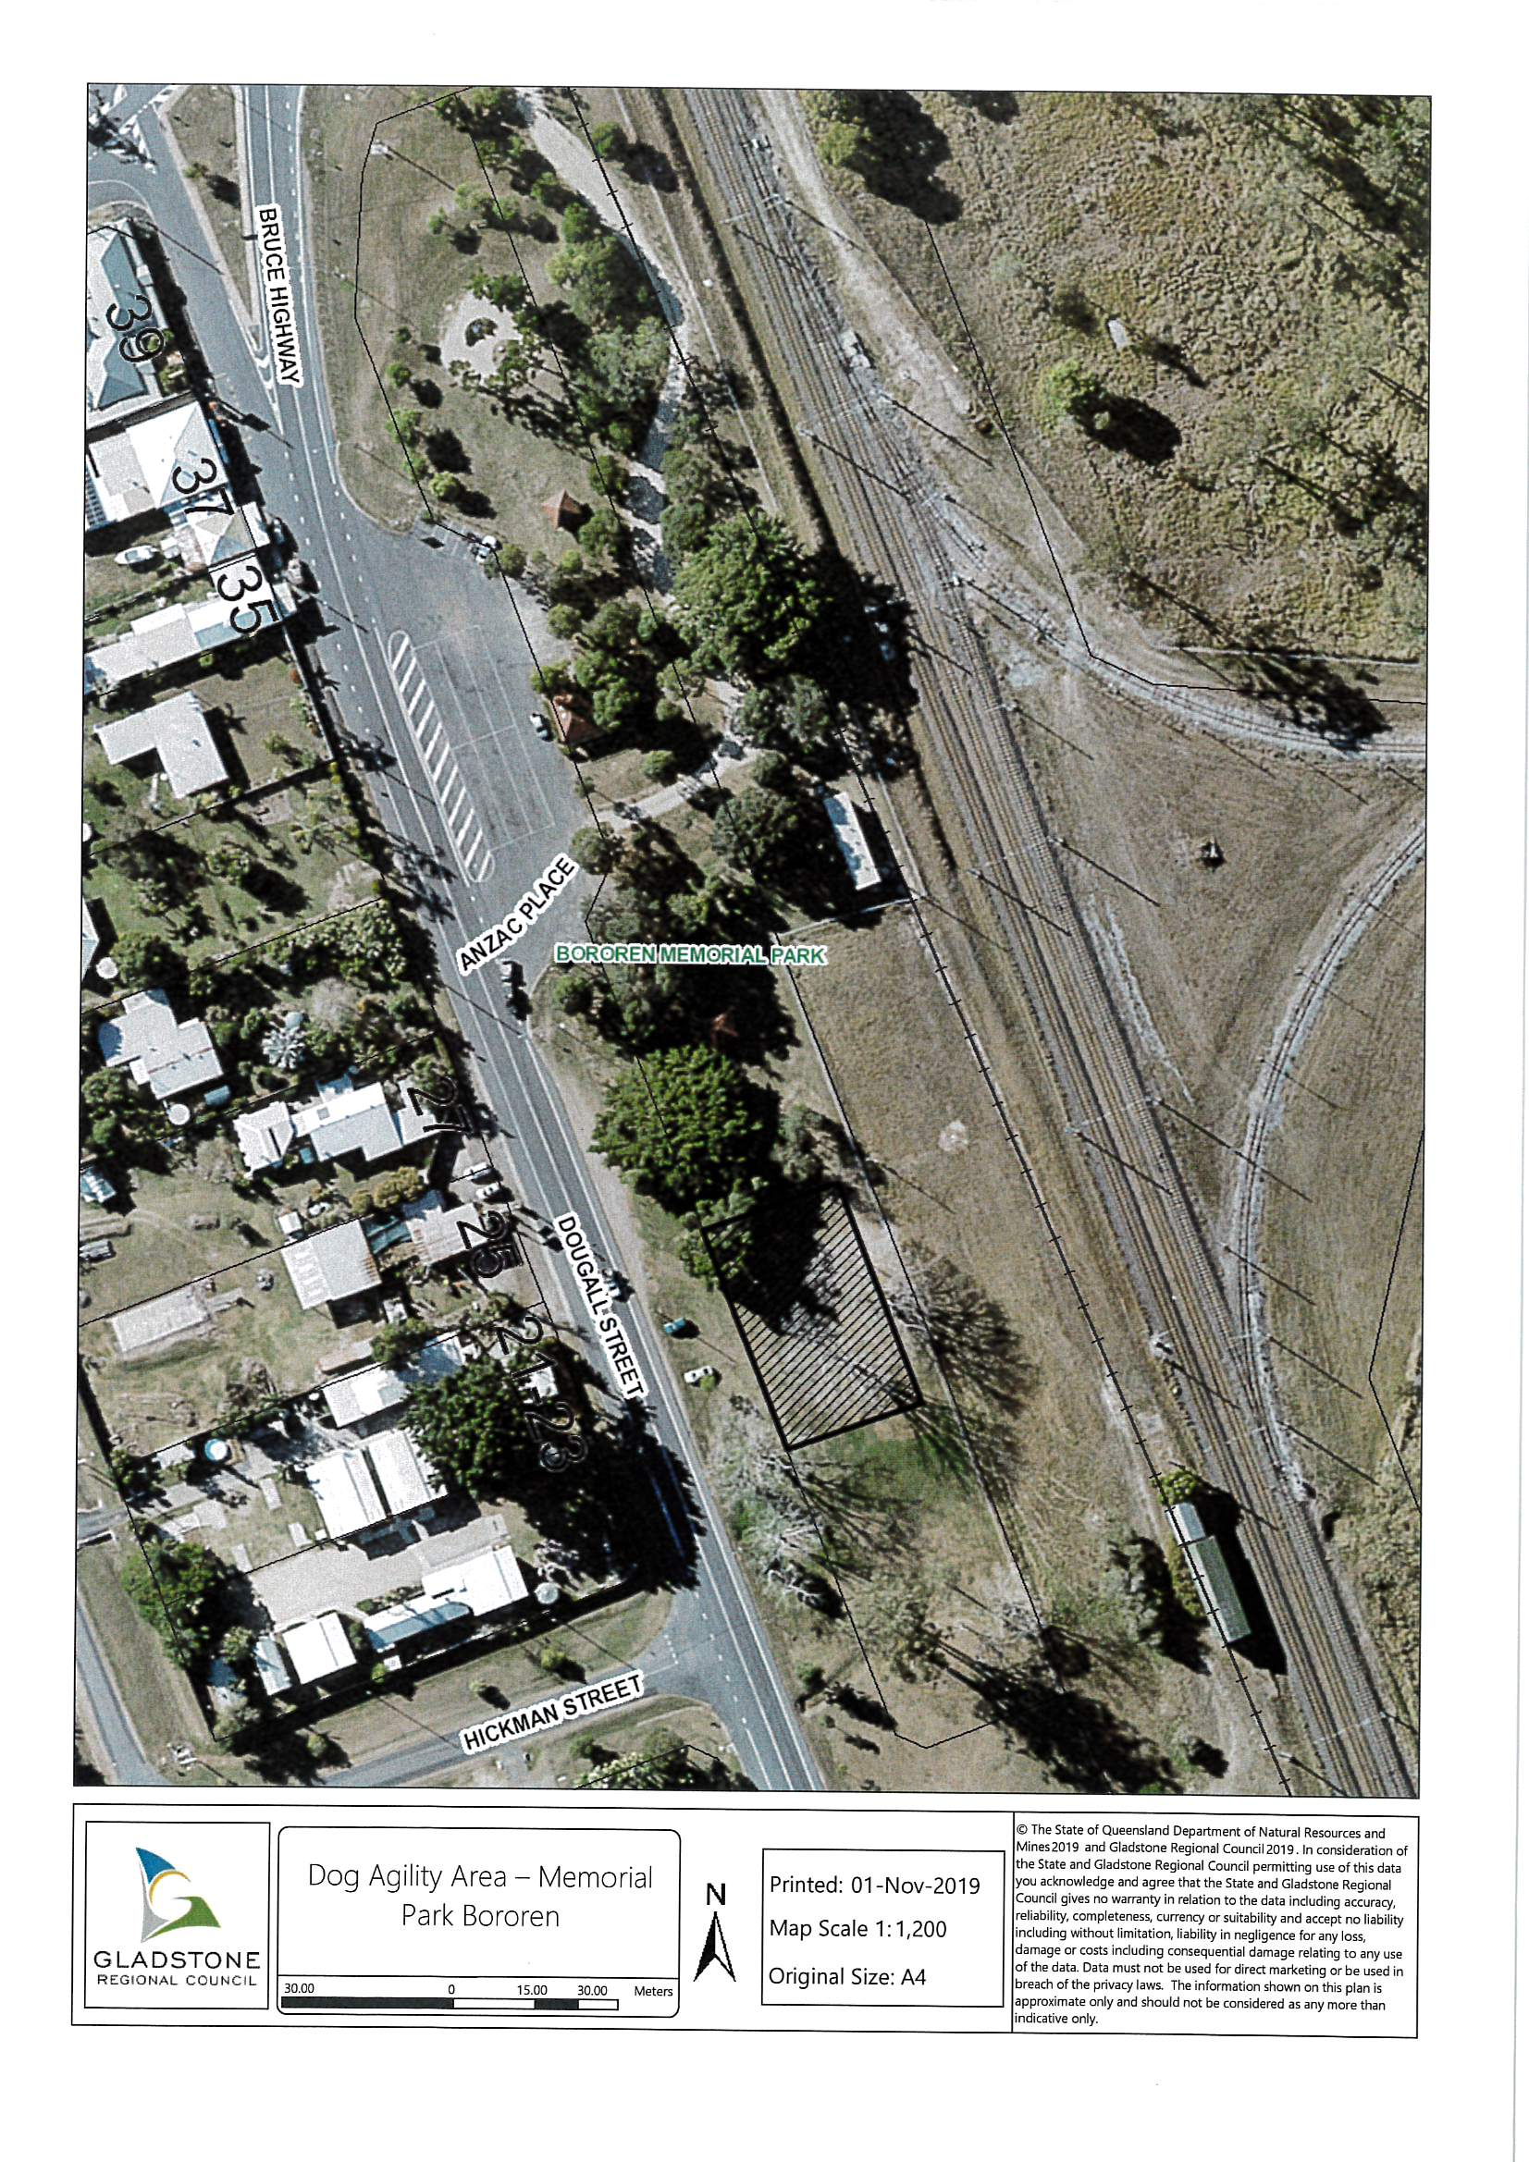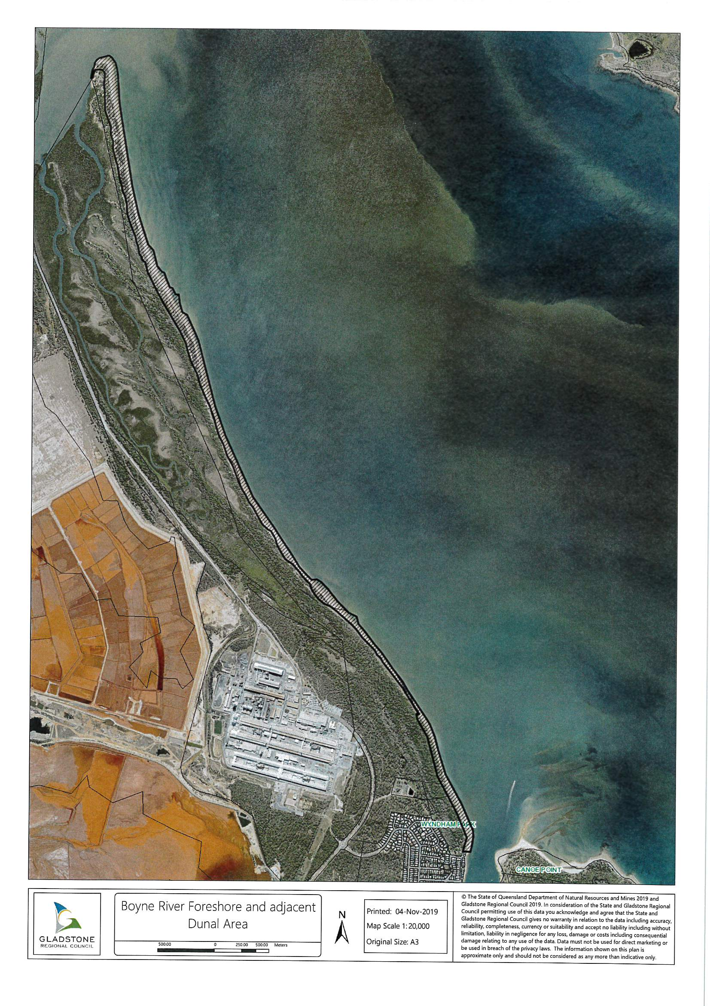

’.

1. Amendment of sch13 (Dictionary)

Schedule 13—

*insert—*

‘***animal***, for each of schedules 1, 5 and 6, and in relation to an animal which is a horse, donkey, cow, bull, camel, deer, sheep, goat, llama or pig, includes a miniature version of the animal.

***poultry***—

1. has the meaning given in the *Biosecurity Act 2014*, schedule 4; but
2. does not include guineafowl, geese, peacocks, peafowl, turkeys or racing pigeons.

***stock***—

1. has the meaning given in the *Animal Management (Cats and Dogs) Act 2008*, schedule 2; but
2. includes pigs.’.

This and the preceding 8 pages bearing my initials is a certified copy of *Animal Management (Amendment) Subordinate Local Law (No. 1) 2019* made in accordance with the provisions of the *Local Government Act 2009* by Gladstone Regional Council by resolution dated the day of 2019.

..............................................................

Chief Executive Officer

870505_1

1. 1A See the definition of ***animal*** in schedule 13 which, in relation to schedule 1, includes a miniature version of various species of animal.
2. 1B See the definition of ***animal*** in schedule 13 which, in relation to schedule 5, includes a miniature version of various species of animal.
3. 1C See the definition of ***animal*** in schedule 13 which, in relation to schedule 6, includes a miniature version of various species of animal.